**COSC422 Assignment 1 Report**

**The Scene**

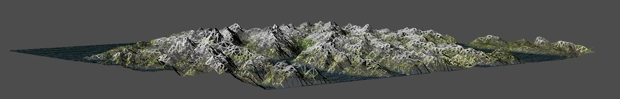

Figure 1 - Scene movement, Less Tessellation Levels (Blocky).

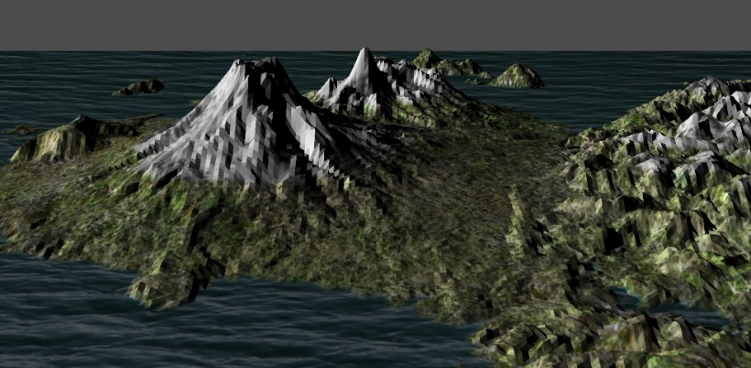

Figure 6 - Scene 2

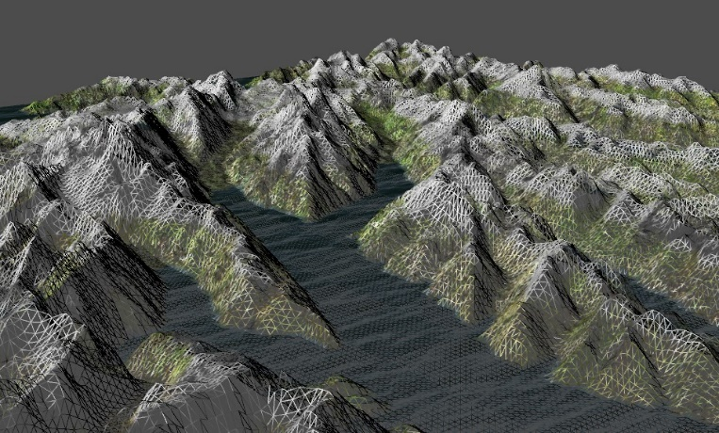

Figure 2 - Scene movement, More Tessellation Levels (Detailed).

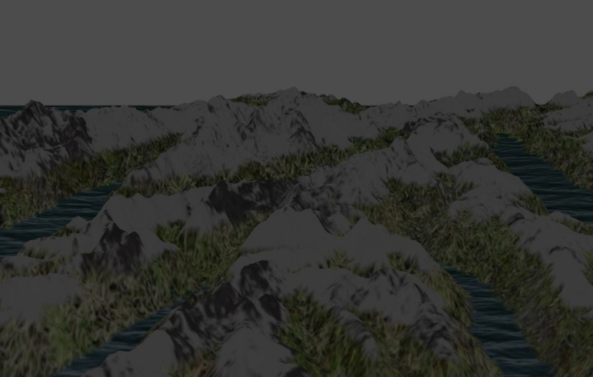

Figure 3 - Ambient Lighting

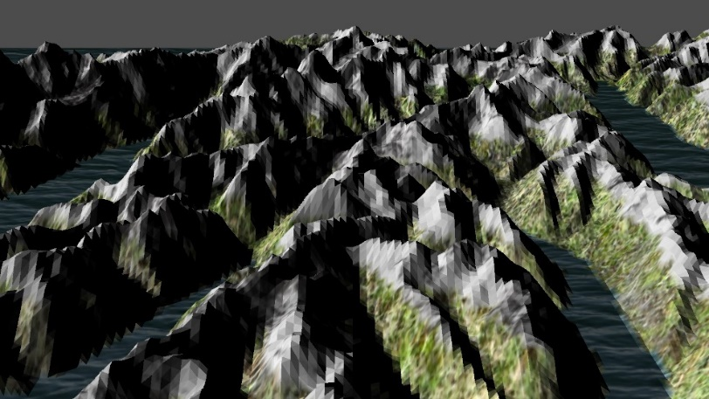

Figure 4 - Ambient + Diffuse Lighting

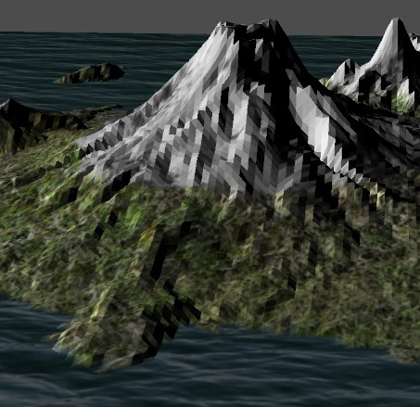

Figure 5 - Blending

Figure 8 - Cracking Fix, white background

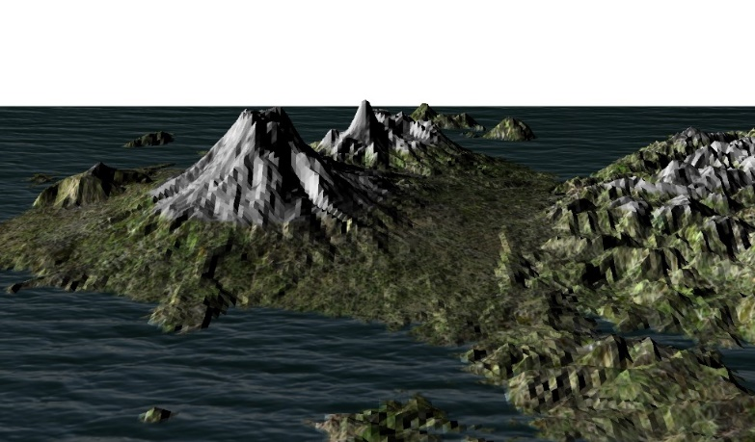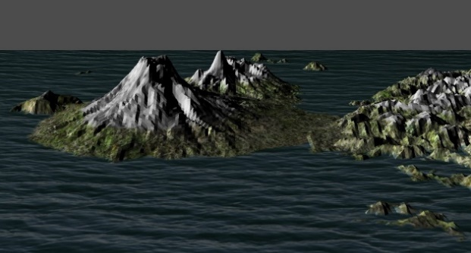

Figure 9 - Adjustable Water level

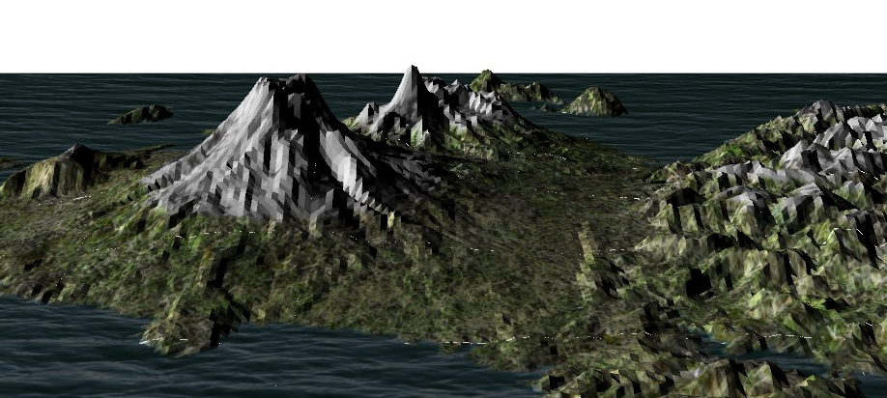

Figure 7 - Cracking Issue, white background

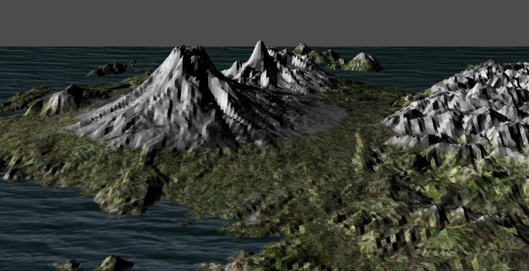

Figure 10 - Adjustable Snow level

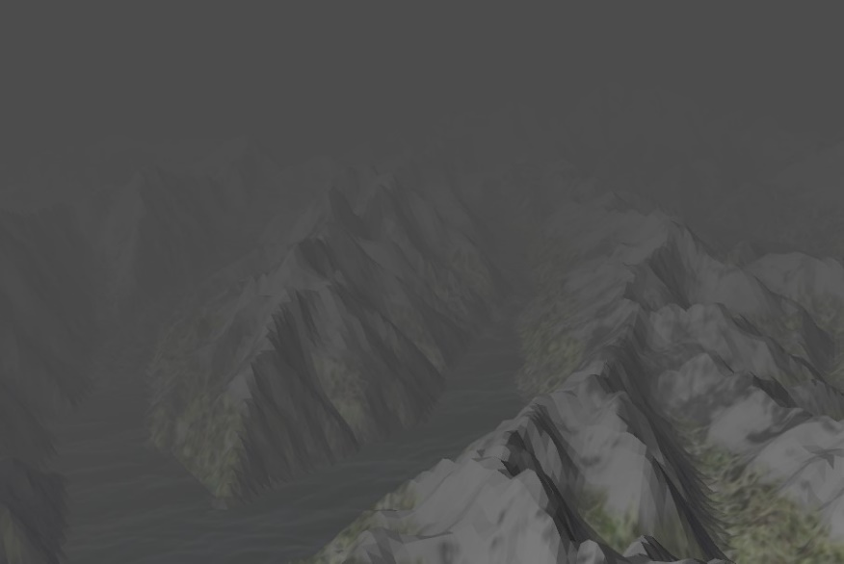

Figure 11 - Fog

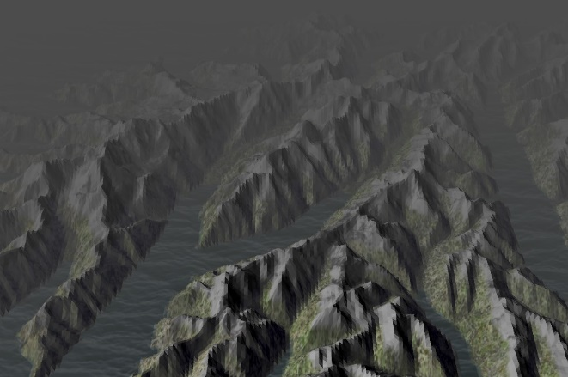

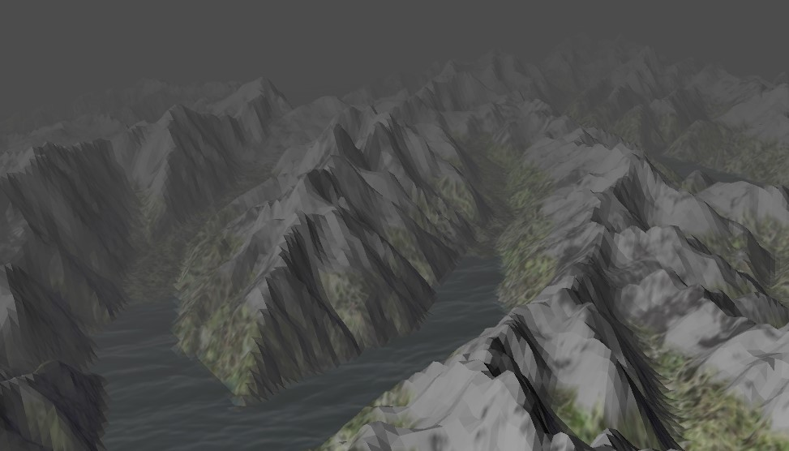

Figure 12 - Adjustable Fog density level

Figure 13 - Adjustable Fog density level

**Basic Terrain Model**

1. **Dynamic level of detail – Camera movement:**

* Toggle wireframe view, * move camera, * toggle wireframe - spacebar, tess level decrease (further away), more levels closer – controlled in the control shader. * (have cracking issue using Equation)

Fig 1 & 2

1. **Lighting:** Geometric shader includes ambient + diffuse lighting – Face normals, tried vertex normals (but unsuccessful)

Fig 3, 4

1. **Textures: \*** Water, *snow, *grass, adjustable snow and water levels, *blending (show weighting Eq)

Fig 5

1. **Terrain Models:** Used MtCook & MtRuapehu height maps, ‘1’ is MtCook and ‘2’ is MtRuapehu

Fig 6 (scene 2) & 4 (scene 1)

**Extra features**

1. **Cracking:** *Was solved via calculating for the length instead (show Equation)

change background to show issue, grey background hides it, Fig 7 & 8

1. **Adjustable water levels:** *Show this * buttons …, Fig 9
2. **Adjustable snow levels:** * Show this * buttons …, Fig 10
3. **Fog:** * Show this, toggle ‘f’ * Show equation, Fig 11
4. **Adjustable Fog Level:** *change fog density, Inc. ‘e’, dec. ‘d’, Fig 12
5. **Smooth Shadding attempt:** show equations (in the fragment shader)
6. **Extra Buttons:** c, Figh 13

**Control Functions**

1. ↑: Moves the camera forwards.
2. ↓: Move the camera backwards.
3. ←: Turn the camera left.
4. →: Turn the camera right.
5. Spacebar: Toggles between wireframe and textured view.
6. '1': Displays Height Map 1
7. '2': Displays Height Map 2
8. '+' or '=': Decreases the cameras height
9. '-':  Increases the cameras height
10. 'c': Toggle cracking
11. 'q': Increases water level
12. 'a': Decreases water level
13. 'w': Increases snow level
14. 's': Decreases  snow level
15. 'f': Toggle fog
16. 'd': Decreases  fog density
17. 'e': Increases fog density
18. 'l': Toggle light shading
19. 'b': Toggle sky color

**Compiling & Running Application**

On a Windows Machine in the Makefile level, type: ‘make && make program’

**References to Sources**

* Height Maps from the lab.
* All mesh models from <https://www.textures.com/library>
* JPG to TGA converter <https://www.freeconvert.com/jpg-to-tga>